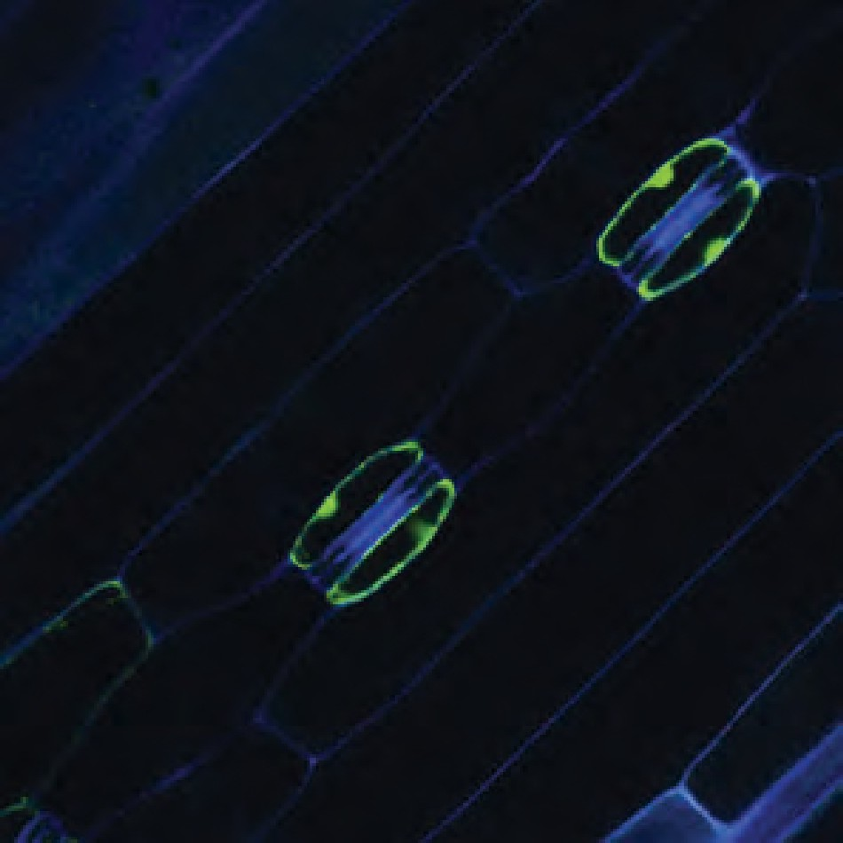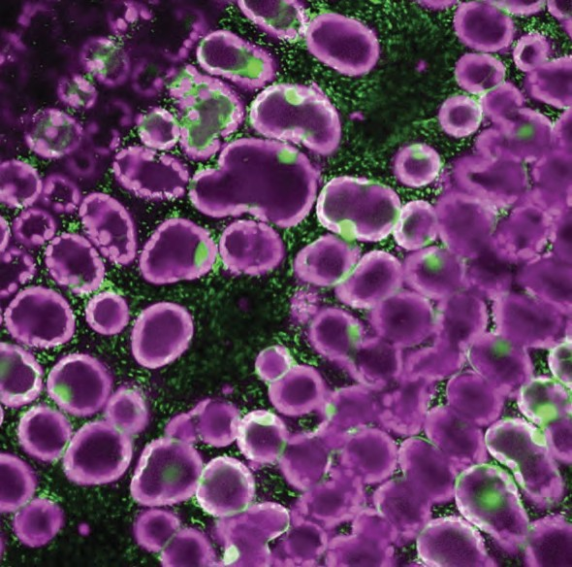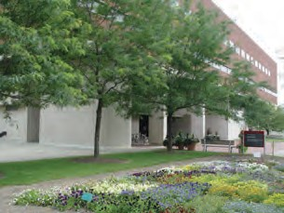SAVE THE DATE
FGW 2020

PRACTICAL SUMMER WORKSHOP IN FUNCTIONAL GENOMICS
FOCUS ON PLANT-MICROBE INTERACTIONS
METABOLOMICS PHYTOBIOME TRANSPOSON SEQUENCING FLUORESCENT IMAGING

MAY 30 - JUNE 13, 2020
THE OHIO STATE UNIVERSITY
CENTER FOR APPLIED PLANT SCIENCES COLUMBUS, OH, USA

EVENT WEBPAGE: CAPS.OSU.EDU/FGW-2020

